

[**Sardar Vallabhbhai National Institute of Technology**](https://en.wikipedia.org/wiki/Sardar_Vallabhbhai_National_Institute_of_Technology,_Surat)

**Project Report on**

“Student Chapters Fund Allocation System”

**Subject: Software Tools- III**

**Academic Year: 2019-20**

**Submitted By:** Sameer Yadav (U17CO087)

**B.Tech (CO) - III**

**5th Semester**

**Jury Signature Student’s Signature**

**Student Chapters Fund Allocation System**

In a nutshell

Student Chapters are an integral part of the college environment. These chapters focus on activities within and outside the boundaries of academics. The project is aimed at managing different student chapters and also helping them by allocating proper funds for different activities that they plan for the academic year.

The administrator can view pending requests from different student clubs along with the breakdown of cost of each event, analyse the previous budgets and allocate funds accordingly. The administrator can also review new club requests from upcoming clubs and initiate them formally by adding them into the official database.

The student chapters can generate request for funds, view their pending requests and also look into their previously allotted budget. The only condition here is that they cannot generate multiple requests unless all their previous requests have been granted.

New student chapters who wish to be formally included in the institute can also apply for the administrator's consideration.

**Features :-**

I. A new student chapter who wishes to formally join the institute and enjoy all the official privileges can register for administrator's consideration.

II. The Administrator and Student Chapters can login securely using their designated username and passwords.

III. Cookies are maintained for every login for a specific period of time to avoid misuse of the platform.

IV. The Admin can view all pending requests under the respective tab, and allocate them funds by looking at the breakdown of total cost for each event. He/ She can also view previously allotted funds as a guideline. Finally he can see requests from new clubs who wish to be formally inducted as an official student chapter.

V. A Student Chapter can generate a request for funds from the administrator, view pending requests and previously granted requests.

VI. A logout system has been designed for both admin and the student chapters to safely logout from the platform.

**Process Flow Diagram:-**

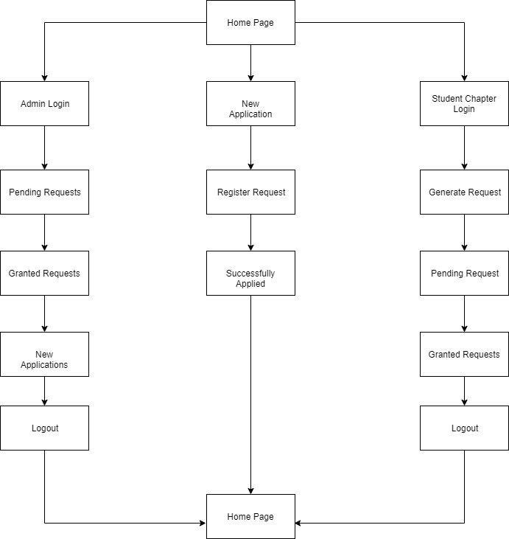

**A Look At All the Pages**

**The Home Page:**

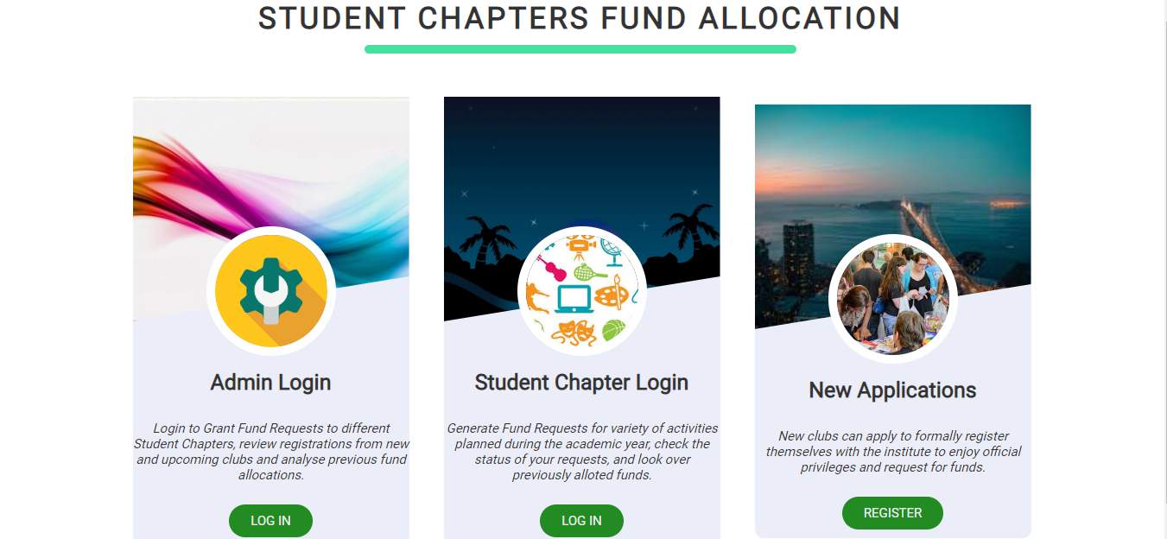

The home page is designed as a card based UI which gives 2 login options(Admin and Student Chapters) and the last card is for new club applications.

**Admin Login:**

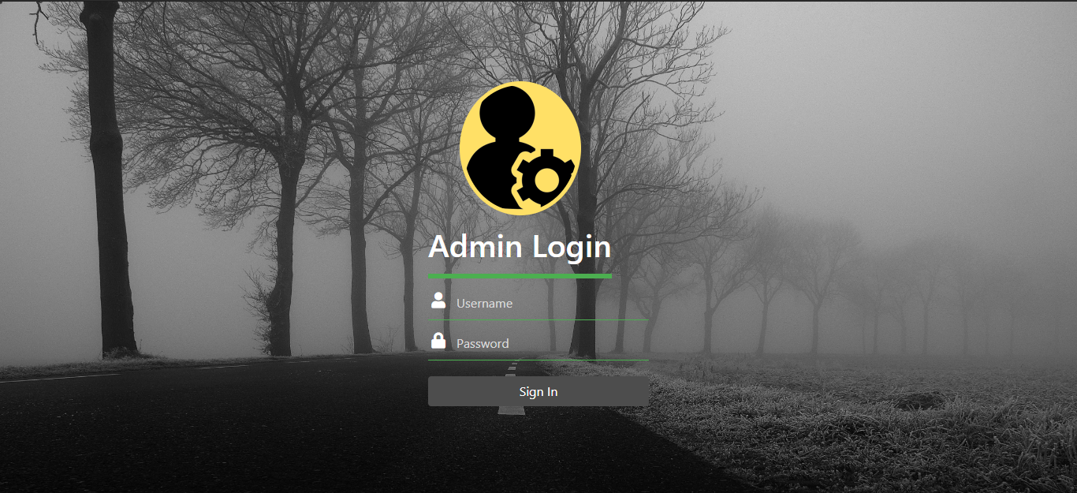

Login Page for Administrator to grant secure access to his/her dashboard.

**Student Chapter Login :**

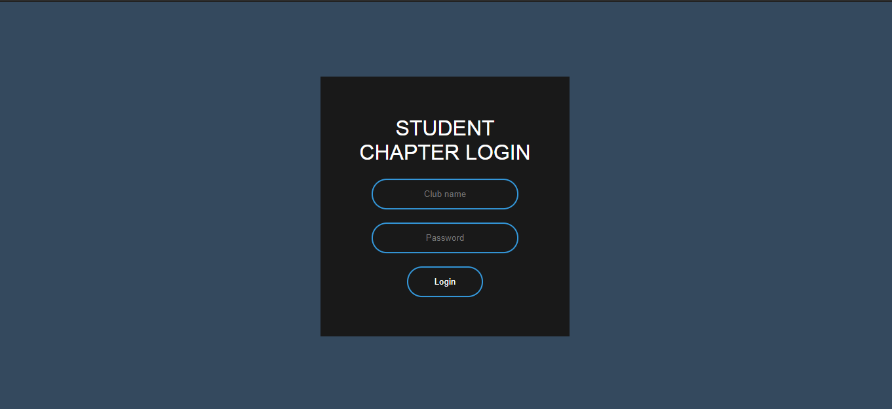

Login Page for Student Chapter to grant secure access to their dashboard.

**New Club Requests :**

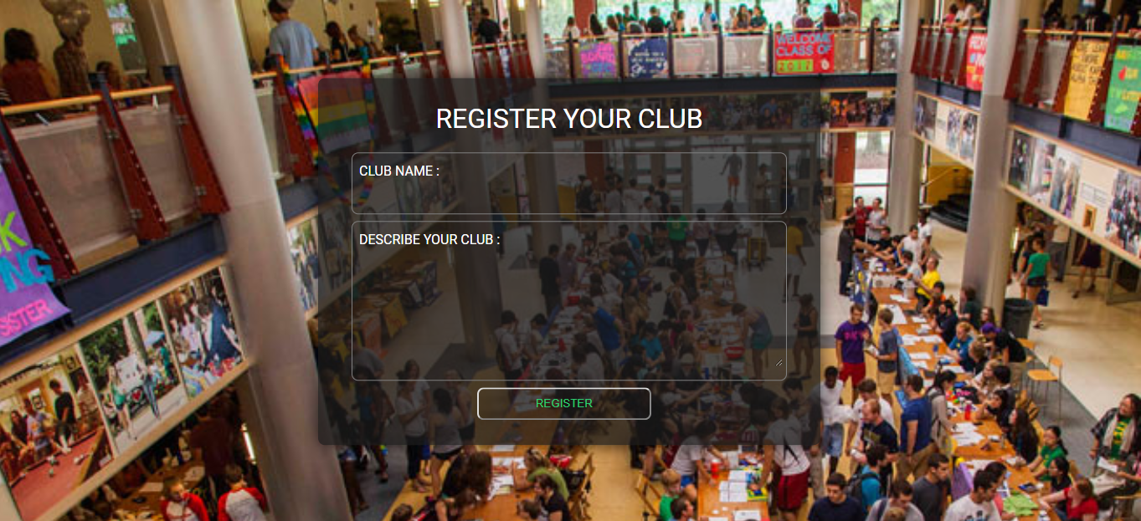

New Clubs can apply here to be formally inducted into the institute.

**Admin Access Pages:**

**Pending Requests -**

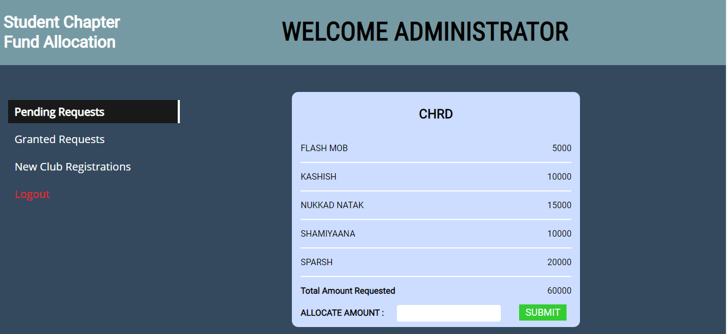

View all pending fund requests from different clubs.

**Granted Requests-**

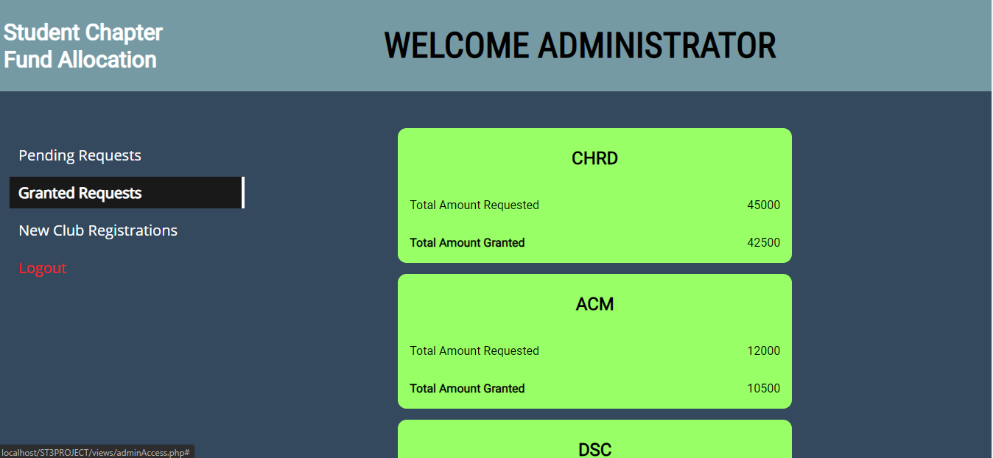

View all previously granted funds to different clubs.

**New Club Requests-**

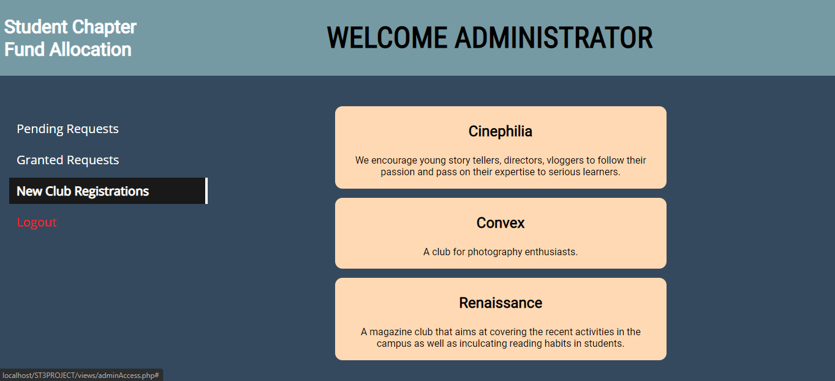

See all new clubs who wish to be formally inducted as a student chapter.

**Add Student Chapter-**

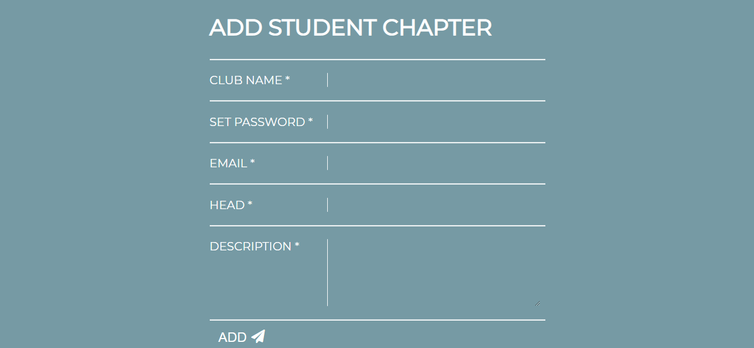

Add new clubs from the previous page to the database and fill all requisite details.

**Student Chapter Access Pages:**

**Request Funds-**

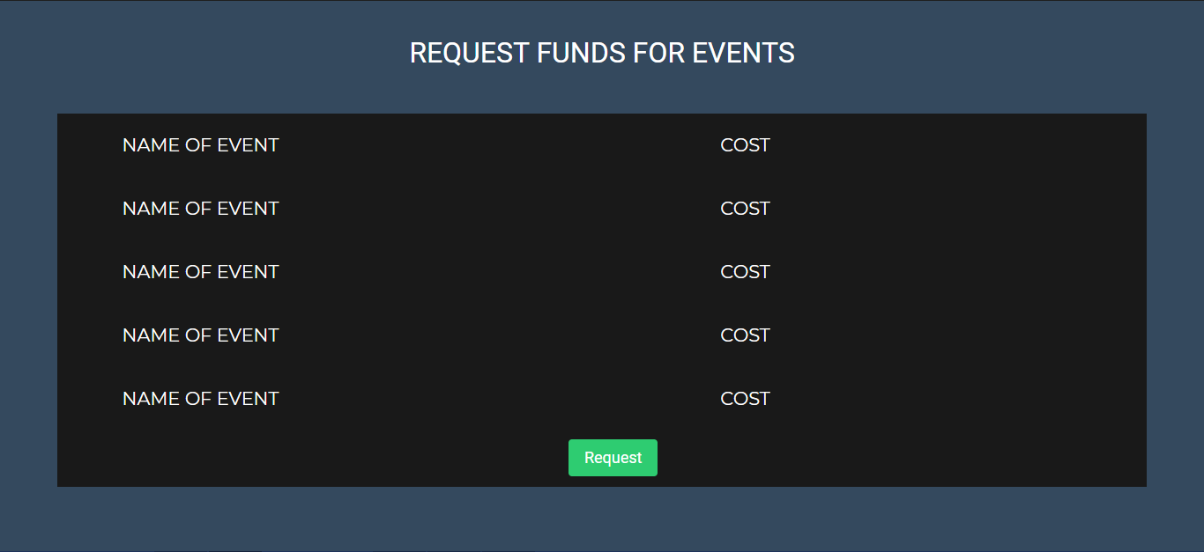

A form to request funds from the Admin.

**Pending Requests-**

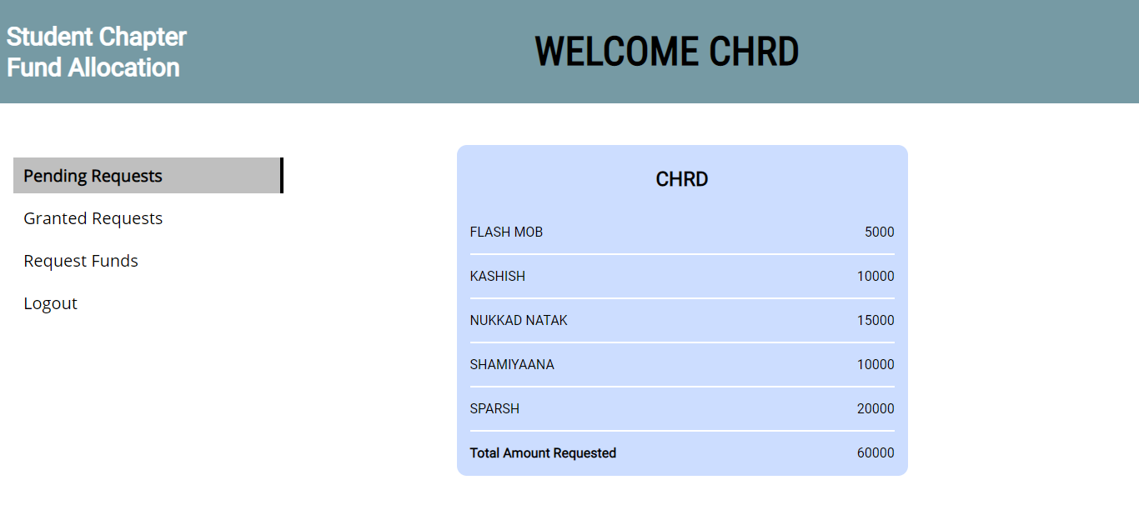

View all pending fund requests that were sent prior.

**Granted Request-**

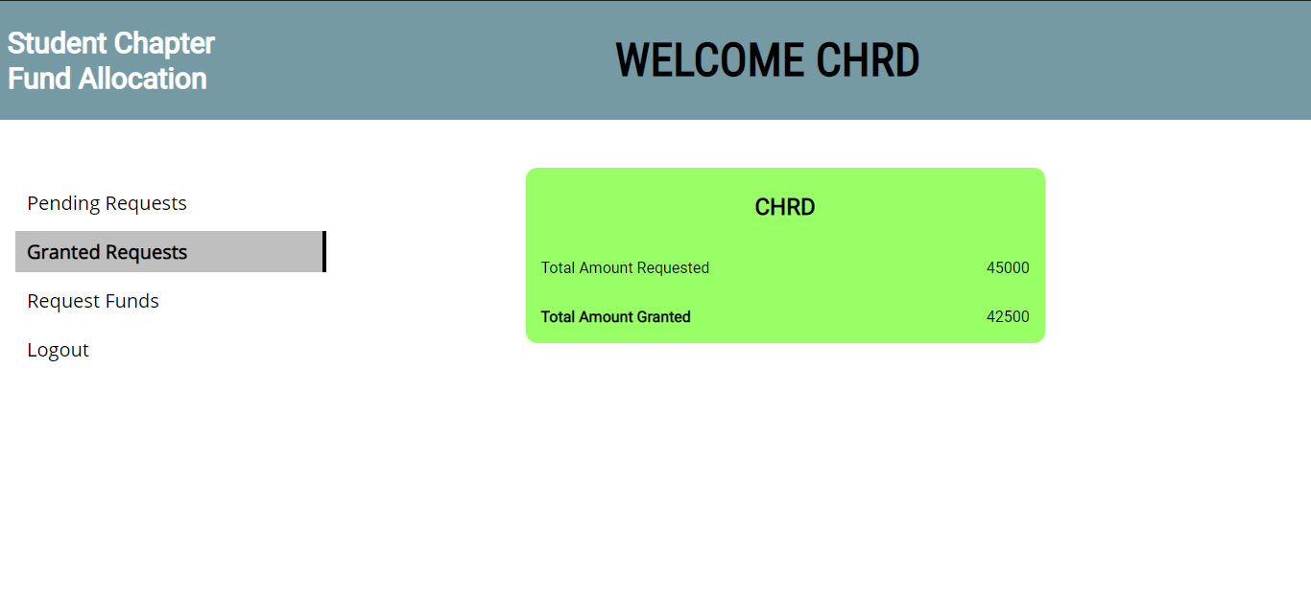

View all granted requests till date.

**The Database-**

